Force - 04
CLASS 09 - SCIENCE

 | Section A
1 | Assertion (A): While catching a fast - moving cricket ball, a fielder in the ground gradually pulls his hands backwards. Reason (R): The fielder increases the time during which the high velocity of the moving ball decreases to zero.  a) Both A and R are true and R is the correct explanation of A.  b) Both A and R are true but R is not the correct explanation of A.  c) A is true but R is false.  d) A is false but R is true. | [1]
2 | Assertion (A): The first law of motion is also known as the law of inertia. Reason (R): Newton’s first law of motion states that a body at rest will remain at rest, and a body in motion will continue in motion in a straight line with a uniform speed unless it is compelled by an external force to change its state of rest or of uniform motion.  a) Both A and R are true and R is the correct explanation of A.  b) Both A and R are true but R is not the correct explanation of A.  c) A is true but R is false.  d) A is false but R is true. | [1]
3 | Assertion (A): While walking on ice, one should take small steps to avoid slipping. Reason (R): This is because smaller steps ensure smaller friction.  a) Both A and R are true and R is the correct explanation of A.  b) Both A and R are true but R is not the correct explanation of A.  c) A is true but R is false.  d) A is false but R is true. | [1]
4 | Assertion (A): When astronauts throw something in space, that object would continue moving in the same direction and with the same speed. Reason (R): The acceleration of an object produced by a net applied force is directly related to the magnitude of the force, and inversely related to the mass of the object.  a) Both A and R are true and R is the correct explanation of A.  b) Both A and R are true but R is not the correct explanation of A.  c) A is true but R is false.  d) A is false but R is true. | [1]
5 | Assertion (A): Mass is a measure of inertia of the body in linear motion. Reason (R): Greater the mass, greater is the force required to change its state of rest or motion.  a) Both A and R are true and R is the correct explanation of A.  b) Both A and R are true but R is not the correct explanation of A.  c) A is true but R is false.  d) A is false but R is true. | [1]
6 | Assertion (A): A body is momentarily at rest when it reverses the direction. Reason (R): A body cannot have acceleration if its velocity is zero at a given instant of time.  a) Both A and R are true and R is the correct explanation of A.  b) Both A and R are true but R is not the correct explanation of A.  c) A is true but R is false.  d) A is false but R is true. | [1]
7 | Assertion (A): When a bullet is fired from a gun, there is a forward force on the bullet and recoil of gun. Reason (R): Every action has an equal and opposite reaction.  a) Both A and R are true and R is the correct explanation of A.  b) Both A and R are true but R is not the correct explanation of A.  c) A is true but R is false.  d) A is false but R is true. | [1]
8 | Assertion (A): The momentum (p) of a body is defined as the product of its mass (m) and velocity (v) and has the same direction as that of the velocity. Reason (R): Its SI unit is kilogram meter per second (kg m s $​^{−1}$ ).  a) Both A and R are true and R is the correct explanation of A.  b) Both A and R are true but R is not the correct explanation of A.  c) A is true but R is false.  d) A is false but R is true. | [1]
9 | Assertion (A): Force exerted by the ground on the man moves him forward. Reason (R): It is a reactional force.  a) Both A and R are true and R is the correct explanation of A.  b) Both A and R are true but R is not the correct explanation of A.  c) A is true but R is false.  d) A is false but R is true. | [1]
10 | Assertion (A): The third law of motion states that when one object exerts a force on another object, the second object instantaneously exerts a force back on the first. Reason (R): The two forces are always equal in magnitude but opposite in direction.  a) Both A and R are true and R is the correct explanation of A.  b) Both A and R are true but R is not the correct explanation of A.  c) A is true but R is false.  d) A is false but R is true. | [1]
11 | Assertion (A): Inertia is that property of the body due to which it resists a change in its state of rest or of uniform motion. Reason (R): Heavy objects have less inertia than lighter objects.  a) Both A and R are true and R is the correct explanation of A.  b) Both A and R are true but R is not the correct explanation of A.  c) A is true but R is false.  d) A is false but R is true. | [1]
12 | Assertion (A): When we sit on a chair, our body exerts a force downward and that chair needs to exert an equal force upward or the chair will collapse. Reason (R): The third law says that for every action there is an equal and opposite reaction.  a) Both A and R are true and R is the correct explanation of A.  b) Both A and R are true but R is not the correct explanation of A.  c) A is true but R is false.  d) A is false but R is true. | [1]
13 | Assertion (A): In a cricket match, when a cricket ball is hit by a bat, then the direction of the cricket ball changes. Reason (R): It shows that a force can change the shape and size of a moving body.  a) Both A and R are true and R is the correct explanation of A.  b) Both A and R are true but R is not the correct explanation of A.  c) A is true but R is false.  d) A is false but R is true. | [1]
14 | Assertion (A): Newton’s third law applies to all types of forces. e.g. gravitational, electric, or magnetic forces, etc. Reason (R): Newton’s third law of motion is applicable only when bodies are in motion.  a) Both A and R are true and R is the correct explanation of A.  b) Both A and R are true but R is not the correct explanation of A.  c) A is true but R is false.  d) A is false but R is true. | [1]
15 | Assertion (A): When a gun is fired, it exerts a forward force on the bullet. Reason (R): The bullet exerts an equal and opposite reaction force on the gun.  a) Both A and R are true and R is the correct explanation of A.  b) Both A and R are true but R is not the correct explanation of A.  c) A is true but R is false.  d) A is false but R is true. | [1]
16 | Assertion (A): If the net external force on the body is zero, then its acceleration is zero. Reason (R): Acceleration does not depend on force.  a) Both A and R are true and R is the correct explanation of A.  b) Both A and R are true but R is not the correct explanation of A.  c) A is true but R is false.  d) A is false but R is true. | [1]
17 | Assertion (A): If the resultant of all the forces acting on a body is zero, then the forces are called balanced forces. Reason (R): The forces acting on a stationary box is an example of balanced forces.  a) Both A and R are true and R is the correct explanation of A.  b) Both A and R are true but R is not the correct explanation of A.  c) A is true but R is false.  d) A is false but R is true. | [1]
18 | Assertion (A): If we kick a football it will move a long way. Reason (R): The inertia of an object is measured by its mass.  a) Both A and R are true and R is the correct explanation of A.  b) Both A and R are true but R is not the correct explanation of A.  c) A is true but R is false.  d) A is false but R is true. | [1]
19 | Assertion (A): Force required to accelerate a mass in two perpendicular directions is never same. Reason (R): The presence of g will not influence the acceleration.  a) Both A and R are true and R is the correct explanation of A.  b) Both A and R are true but R is not the correct explanation of A.  c) A is true but R is false.  d) A is false but R is true. | [1]
 | Section B
20 | State Newton’s second law of motion. | [1]
21 | When a force acting on a body has equal and opposite reaction, then why should the body move at all? | [1]
22 | Define 1 newton force. | [1]
23 | Does Newton’s third law apply to a system where bodies do not actually touch each other? | [1]
24 | What do balanced forces usually do to a body? | [1]
25 | Write the C.G.S unit of force. | [1]
26 | Define electrostatic force. | [1]
27 | Why do bicycles begin to slow down when we stop pedalling? | [1]
28 | Define force of friction. | [1]
29 | Why mass is sometimes called coefficient of linear inertia? | [1]
30 | Which law of motion gives the measure of force? | [1]
31 | Why does a mug full of water feel lighter inside water? | [1]
32 | Name the scientist who proved for the first time that objects move with constant speed when no force acts on them. | [1]
33 | State Newton’s first law of motion. | [1]
34 | Body A is heavier than body Q. Which has more inertia? | [1]
35 | When a body moves on a flat surface, will its speed change? | [1]
36 | Suppose a ball of mass ’m’ is thrown vertically upwards with an initial speed ’v’, its speed decreases continuously till it becomes zero. Therefore, the ball begins to fall downward and attains the speed ’v’ again before striking the ground. It implies that the magnitude of initial and final momenta of the ball are same. Yet, it is not an example of conservation of momentum. Explain why. | [1]
37 | Do action and reaction act on the same body? | [1]
38 | Plot a graph between force applied on a body and the acceleration produced in the given mass, assuming that the magnitude of force it constantly changing. | [1]
39 | Does every force produce motion in every object? | [1]
40 | What did Galileo conclude on the basis of his experiments on the motion of objects? | [1]
41 | If the body is found to be accelerated, is the force acting on it balanced or unbalanced? | [1]
42 | What do you mean by a resultant force? | [1]
43 | Using a horizontal force of 200 N, we intend to move a wooden cabinet across a floor at a constant velocity. What is the friction force that will be exerted on the cabinet? | [1]
44 | The velocity - time graph of an object of mass m = 50 g is shown in the figure. Observe the graph carefully and answer the following questions.  - Calculate the force on the object in time interval 0 to 3 s.  - Calculate the force on the object in the time interval 6 to 10 s.  - Is there any time interval in which no force acts on the object? Justify your answer. 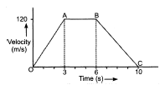 | [3]
45 | The motion of a body of mass 5 kg is shown in the velocity - time graph. 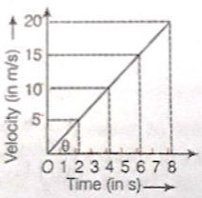  Find from the graph  - The acceleration.  - The force acting on the body.  - The change in momentum of the body in 2 s after the start. | [3]
46 | A bullet travelling at 360 m/s strikes a block of soft wood. The mass of the bullet is 2.0 g. The bullet comes to rest after penetrating 10 cm into the wood.a) Find the average de - accceleration force exerted by the wood. b) Find the time taken by the bullet to come to rest. | [3]
47 | Give reason for the following:  - Road accidents occurring due to high speeds are much worse than accidents due to low speeds of vehicles.  - When a motorcar makes a sharp turn at a high - speed, passengertends to get thrown to one side. | [3]
48 | The velocity - time graph of a ball moving on the surface of floor is shown in the figure. Calculate the force acting on the ball, if the mass of the ball is 100 g. 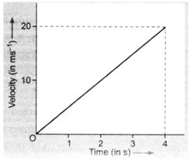 | [3]
49 | - Explain, why is it difficult to walk on sand?  - Why is the recoil of a heavy gun, on firing, not so strong as that of a light gun using the same cartridge? | [3]
50 | The speed - time graph of a car is given. The car weighs 1000 kg.  - What is the distance travelled by car in the first 2s?  - What is the braking force applied at the end of 5 s to bring the car to stop within one second? 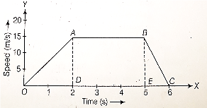 | [3]
51 | Akhtar, Kiran and Rahul were riding in a motor car that was moving with a high velocity on an express way when an insect hit the windshield and got stuck on the windscreen. Akhtar and Kiran started pondering over the situation. Kiran suggested that the insect suffered a greater change in momentum as compared to the change in momentum of the motor car (because the change in the velocity of the insect was much more than that of the motor car). Akhtar said that since the motor car was moving with a larger velocity, it exerted a larger force on the insect and as a result ,the insect died. Rahul while putting an entirely new explanation said that both the motor car and the insect experienced the same force and a change in their momentum. Comment on these suggestions. | [3]
52 | The velocity - time graph of a ball moving on the surface of a floor is shown in the figure. Find the force acting on the ball if the mass of the ball is 50 g. 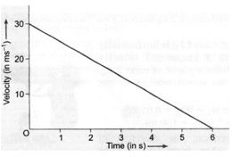 | [3]
53 | The following is the distance - time table of an object in motion: 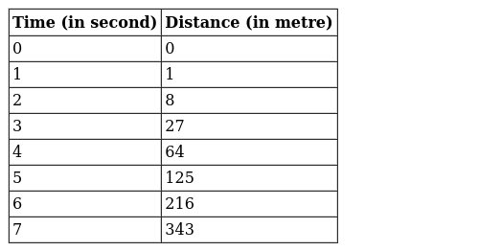  - What conclusion can you draw about the acceleration? Is it constant, increasing, decreasing or zero?  - What do you infer about the force acting on the object? | [3]
54 | The following is the distance - time table of an object in motion: 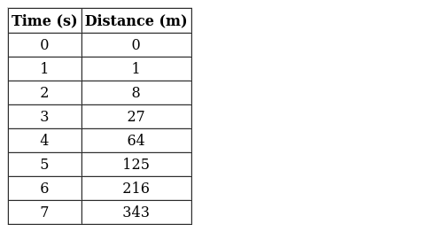  - What conclusion can you draw about the acceleration? Is it constant, increasing, decreasing, or zero?  - What do you infer about the forces acting on the object? | [3]
55 | Look at the diagram below and answer the following questions: 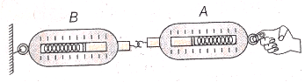  - When a force is applied through the free end of the spring balance A, then the reading on the spring balance A is 15 g - wt. What will be the measure of the reading shown by spring balance B?  - Write the reasons for your answer.  - Name the force that balance A exerts on balance B and the force of balance B on balance A. | [3]
56 | The velocity - time graph of a ball moving on the surface of the floor is as shown in the figure. Calculate the force acting on the ball, if mass of the ball is 100 g. 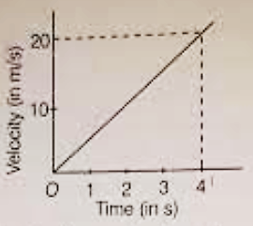 | [3]
57 | Give a reason for the following questions:  - It is difficult to balance our body when we accidentally step on a peel of a banana.  - Pieces of bursting crackers fall in all possible directions.  - A glass pane of a window is shattered when a flying pebble hits it.  - It is easier to stop a tennis ball than a cricket ball moving at the same speed.  - A javelin thrower is marked foulif an athlete crosses over the line marked for the throw. Athletes often fail to stop themselves before the line. | [5]
58 | Derive the mathematical relation of Newton’s second law of motion. | [5]
59 | Define balanced and unbalance forces. Why is acceleration of a body not possible under the action of balanced forces? | [5]
60 | - State second law of motion.  - A bus starts from the stop and take 20 second to get the speed of 10m/s. If the mass of the bus along with passengers is 10000 kg, calculate the force applied by the engine of bus to push the bus at the speed of 10m/s. | [5]
61 | Two identical bullets are fired one by a light rifle and another by a heavy rifle with the same force. Which rifle will hurt the shoulder more and why? | [5]
62 | What is momentum? Write its SI unit. Interpret force in terms of momentum. Represent the following graphically:  - Momentum versus velocity when mass is fixed.  - Momentum versus mass when velocity is constant. | [5]
63 | Two hockey players of opposite teams, while trying to hit a hockey ball on the ground collide and immediately become entangled. One has a mass of 60 kg and was moving with a velocity of 5.0 ms$​^{−1}$ while the other has a mass of 55 kg and was moving faster with a velocity of 6.0 ms $​^{−1}$ towards the first player. In which direction and with what velocity will they move after they become entangled? Assume that the frictional force acting between the feet of the two players and the ground is negligible. | [5]
64 | Describe Newton’s first law of motion in detail, giving examples. | [5]
65 | Describe Newton’s third law of motion. | [5]
66 | A body of mass 2 Kg is at rest at the origin of a frame of reference. A force of 5 N acts on it at t = 0. The force acts for 4 sand then stops.  - What is the acceleration produced by the force on the body?  - What is the velocity at t = 4 s  - Draw the vt graph for the period t = 0 to t = 6 S.  - Find the distance travelled in 6 s. | [5]
67 | State and explain along with example Newton’s laws of motion. | [5]
68 | Define force? Explain five effects of force? | [5]
69 | A 8000 kg engine pulls a train of 5 wagons, each of 2000 kg, along a horizontal track. If the engine exerts a force of 40000 N and the track offers a frictional force of 5000 N, then calculate:(a) the net accelerating force; (b) the acceleration of the train; and (c) the force of wagon 1 on wagon 2. | [5]
70 | Explain the following:  - Why do we jerk wet clothes before spreading them on wire?  - Why does dust flies off when carpet is hit with stick?  - Why fruits fall off the branches in strong wind?  - Why a pillion rider falls forward, when the driver of a two wheeler suddenly applies brakes? | [5]

